Dine and Donate for
Coulee Region RSVP Event
“Who will be Smarter than a 5th Grader”
Team Eagle Bluff-Donna and Anthony
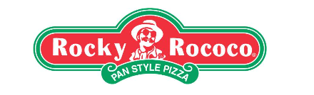
Visit Rocky Rococo Pan Style Pizza
Tuesday, March 10th, 2020
4:00pm-9:00pm
Enjoy a delicious Dinner with Family and Friends at Rocky’s.
Dine in, Take out or Drive-thru
- Rocky Rococo, 1239 Crossing Meadows Dr.
- Rocky Rococo, 40 Copeland Ave.
Present voucher below at time of purchase and
12.5% of your purchase will be donated to
Coulee Region RSVP
-------------------------------------------------------------------------------------------------------------------------------------------------- Please Present at time of purchase
Name _________________________________________________________________________________
I Support Coulee Region RSVP

Total net Sales $_____________ filled out by employee and attach to receipt.

